**Online sources/Videos: Reference Module 1 and 2 Morpohology Integrated Architecture 3 Studio**

**Studio: Dan Faoro, Lab, Eric Ward. Fall 2022**

A useful reference book for this class, for building systems and Codes, the LTU librarian says this safe to use.  Architects Studio Companion

(<https://archive.org/details/The_Architects_Studio_Companion_Rules_of_Thumb_for_Preliminary_Design_5th_Editio>)

This will have all the systems described with span charts and column sizing

<https://issuu.com/bilgeturgut/docs/ching_2014_building_structures_illu>

Building Structural Systems Illustrated 2nd. Ed. By Francis Ching This will show multiple framing systems in configuration and bays and show framing conditions that are not typical.

<https://issuu.com/grimshawarchitects/docs/blue_02>

Blue, Nicolas Grimshaw and Associates,

<https://issuu.com/download-bse/docs/ad_mathematics_of_space>

Mathematics of Space AD special Issue

<https://issuu.com/roland771/docs/3778_advances-in-architectural-geom>

Advances in Architectural Geometry 2016

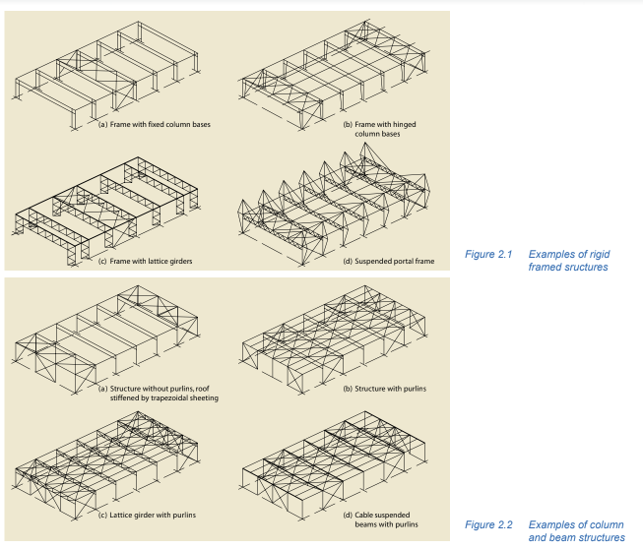

**Online Resources for Module 1and 2 -Morphology**:

***STEEL:***

***Best practices in Industrial Buildings in Steel Construction***, an excellent collection of design considerations for prefabricated steel frames.

<https://vicivil.com/best-practice-in-steel-construction-industrial-buildings-guidance-for-architects-designers-construction/>

<https://pdhonline.com/courses/s120a/s120content.pdf>

<https://www.steelconstruction.info/images/f/fd/SS018a.pdf>

Roof envelopes in steel

<https://www.steelconstruction.info/Single_storey_industrial_buildings>

An overview of standard prefab steel systems.

<https://www.academia.edu/42007228/STEEL_BUILDINGS_IN_EUROPE_Multi_Storey_Steel_Buildings_Part_2_Concept_Design>  

<https://www.academia.edu/32211347/CIM_steel>

<https://www.llentab.com/>

<https://www.china-roof.com/Structural-Steel-Buildings-1279.html>

<https://www.steelconstruction.info/images/9/97/SBE_MS1.pdf>

 TATA Steel Case Studies

<https://www.tatasteelconstruction.com/en_GB/tata-steel-case-studies>

Portal frames in Steel prefab

<https://www.steelconstruction.info/Portal_frames>

Videos on construction <https://www.alliedbuildings.com/videos/>

This is a very good case study

<https://canada.constructconnect.com/dcn/news/projects/2018/09/u-t-steel-prefab-building-anything-plain-jane>

Another case study, it will be useful to see this for Exercise 2.

<https://www.infosteel.be/roestvast-staal-projecten/82-utiliteitsbouw/30-bedrijvencentrum-transinne.html>

Structural Anaylsis of Centre George Pompidou.

<http://faculty.arch.tamu.edu/anichols/courses/applied-architectural-structures/projects-631/Files/PompidouF16.pdf>

Sustainability and Prefabrication

<https://www.buildinggreen.com/feature/potential-prefab-how-modular-construction-can-be-green>

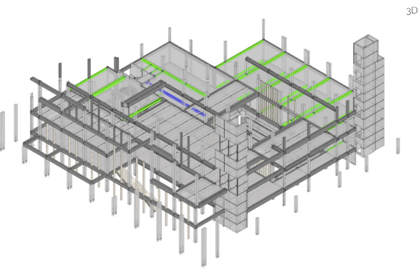<https://www.mdpi.com/2071-1050/8/6/558/htm>

--

**CONCRETE**

**Precast Concrete (2009)** an overview and graduate research document form Northeastern University dept. of Architecture- a useful reference.

https://issuu.com/neuarchitecture/docs/precast_concrete_book

<http://www.uct.ac.za/sites/default/files/image_tool/images/333/Events/PP_2013_2_Precast_Concrete_SA.pdf>.

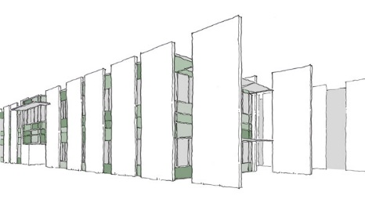Precast case studies

<https://precast.org/blog/case-studies/>

<http://www.lakeflatodogrun.com/field-report/field-report-texas-biomed/>

https://randelliottarchitects.com/portfolio/kj-mcnitt-construction-company/

https://www.architecturalrecord.com/articles/7889-kirkpatrick-oil-field-office

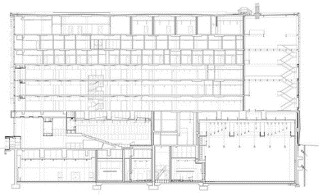<https://www.archdaily.com/12569/new-pavilion-for-the-mcgill-university-schulich-school-of-music-saucier-perrotte-architectes/500f1b8c28ba0d0cc7001b51-new-pavilion-for-the-mcgill-university-schulich-school-of-music-saucier-perrotte-architectes-image?next_project=no>

This is an excellent slide show on these systems, comprehensive and usable for architecture students, I would suggest sharing with your students- as I will be doing. Developed from Ut Delft faculty.

# <http://tilt-up.org/tilt-uptoday/wp-content/uploads/2011/11/CTU-Final-web.pdf>

# <https://www.archdaily.com/800500/biotrial-north-american-headquarters-francis-cauffman?ad_medium=gallery>

# Biotrial North American Headquarters / Francis Cauffman

https://www.pci.org/PCI_Docs/Publications/PCI%20Journal/1999/Sept-Oct/Loadbearing%20Architectural%20Precast%20Concrete%20Wall%20Panels.pdf

Precast Concrete tilt up wall panels. Key information in these articles.

https://www.archdaily.com/800500/biotrial-north-american-headquarters-francis-cauffman?ad_medium=gallery

<http://www.aacpaofficial.com/technical-manual/Construction%20Details.pdf>

Aercon System Load bearing and non- load bearing walls and panels

***TIMBER:***

[***https://www.canadianarchitect.com/mass-timber-primer/***](https://www.canadianarchitect.com/mass-timber-primer/)

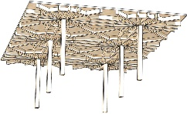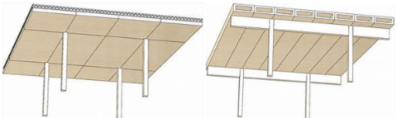**Mass Timber Primer, Nov 13 , 2019** ( This is an excellent resource, I want to see all 18 generic mass timber systems described in your lab report.)

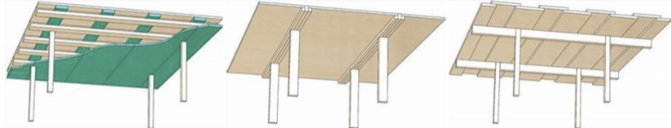

<http://fast10.vsb.cz/temtis/documents/Instruction_handbook_Final_version.p>

Heavy timber Wood Truss Glulam Case studies with details

<https://issuu.com/jamesford64/docs/urban_timber_web>

A comprehensive E-book on mass timber and prefabrication.

***Mass Timber Methods****,* a extensive  189 page overview of these systems,  an architecture research report. Systems descriptions and case studies.

<https://issuu.com/bokapowell/docs/bokapowell_structurecraft_mass_timb>

***Mass Timber Construction: BokaPowell/ Structurecraft***: An 39 page overview with details and case studies .

<http://www.woodworks.org/wp-content/uploads/UMass-Amherst-Olver-Design-Building-WoodWorks-Case-Study.pdf>

The floor in this project is a composite concrete /mass timber system and adds strength and is an innovation to the system

https://structurecraft.com/materials/mass-timber/dlt-dowel-laminated-timber

Dowel . Laminated Timber (DLT)

<https://structurecraft.com/materials/mass-timber/nail-laminated-timber>

NLT ( Nail laminated timber)

<https://issuu.com/markotomicic9/docs/freeform_geometries_in_wood_constru>

Freeform Architecture in Wood

**PREFABRICATION and ARCHITECTURE**

**Prefabricated Systems Principles of Construction**

Published on May 30, 2013   Introduction to prefabricated systems and their potential for architecture

<https://issuu.com/detail-magazine/docs/978-3-7643-8656-6-bk-en-components_>

<https://issuu.com/jdparchitects/docs/scalable_modular_architecture>

Scalable Modular Architecture,

<https://issuu.com/neuarchitecture/docs/prefabcity>

***Prefab City, Examples of prefabrication in urban environments*.** an excellent overview and graduate research document form Northeastern University dept. of Architecture- a useful reference.

**Online Videos about the Structural Systems**

Mass timber videos

<https://youtu.be/FAhuP9CK2Hk>

<https://www.youtube.com/watch?v=vetYAeh9MUI>

<https://www.youtube.com/watch?v=YuAya0hRjwU>

Steel Prefabricated buidings:

Post and beam frame

<https://youtu.be/aoOWzRpeDKo>

Portals  solid beams

<https://youtu.be/Z-7qaTDwkx4>

<https://youtu.be/J0yU7xLxF20>

Portal with trusses

<https://youtu.be/cxlVt5BdGE0>

Steel Arches

<https://www.youtube.com/watch?v=ZnV3m4Vx500>

Precast Concrete - time lapse model

<https://www.youtube.com/watch?v=7Y3ddGdraUQ>

load bearing Wall and slab

Precast Cocrete wall and column beam bearing - time lapse model

<https://youtu.be/YqWjJAv8EDA>

Double  T construction

<https://youtu.be/VgJ6LSqkaIg>

Making wood trusses

<https://youtu.be/MLYAHmvppJs>

https://ssl.gstatic.com/ui/v1/icons/mail/images/cleardot.gif